VB.NET Operators

In **VB.NET** programming, the **Operator** is a symbol that is used to perform various operations on variables. **VB.NET** has different types of Operators that help in performing logical and mathematical operations on data values. The **Operator precedence** is used to determine the execution order of different Operators in the [VB.NET programming language](https://www.javatpoint.com/vb-net).

What is VB.NET Operator?

In VB.NET, **operator** is a special symbol that tells the compiler to perform the specific logical or mathematical operation on the data values. The data value itself (which can be either a variable or a constant) is called an **operand,** and the Operator performs various **operations** on the operand.

**For example:** In the expression,

3 + 2 - 1

The symbol **+** and **-** are the Operators, and the 3, 2, and 1 are operands.

**Different Types of VB.NET Operators**

Following are the different types of Operators available in VB.NET:

* Arithmetic Operators
* Comparison Operators
* Logical and Bitwise Operators
* Bit Shift Operators
* Assignment Operators
* Concatenation Operators
* Miscellaneous Operators

Arithmetic Operators

The Arithmetic Operators in VB.NET, used to perform mathematical operations such as **subtraction, addition, multiplication, division,** etc. on the operands in VB.NET. These are as follows:

**Arithmetic Operators in VB.NET**

|  |  |  |
| --- | --- | --- |
| **Operators** | **Description** | **Example** |
| **^** | It is an exponentiation Operator that is used to raises one operand to the power of another operand. | Y ^ X (X to the power Y) |
| **+** | The addition Operator is used to add numeric data, as well as concatenate two string variables. | X + Y |
| **-** | It is a subtraction Operator, which is used to subtract the second operand from the first operand. | X - Y |
| **\*** | The multiplication Operator is used to multiply the operands | X * Y |
| **/** | It is a division Operator used to divide one operand by another operand and returns a floating-point result. | X / Y |
| **\** | It is an integer division Operator, which is similar to division Operator, except that it returns an integer result while dividing one operand to another operand. | X \ Y |
| **Mod** | It is a modulo (Modulus) Operator, which is used to divide two operands and returns only a remainder. | X Mod Y |

Example of **Arithmetic Operators in VB.NET:**

**Arithmetic_Operator.vb**

Imports System

Module Arithmetic_Operator

    Sub Main()

        'Declare a, b And c as integer Data Type()

        Dim a, b, c As Integer

        Dim d As Single

        a = 17

        b = 4

        ' Use of + Operator

        c = a + b

        Console.WriteLine(" Sum of a + b is {0}", c)

        'Use of - Operator

        c = a - b

        Console.WriteLine(" Subtraction of a - b is {0}", c)

        'Use of * Operator

        c = a * b

        Console.WriteLine(" Multiplication of a * b is {0}", c)

        'Use of / Operator

        d = a / b

        Console.WriteLine(" Division of a / b is {0}", d)

        'Use of \ Operator

        c = a \ b

        Console.WriteLine(" Similar to division Operator (return only integer value) of a - b is {0}", c)

        'Use of Mod Operator

        c = a Mod b

        Console.WriteLine(" Modulus of a Mod b is {0}", c)

        'Use of ^ Operator

        c = a ^ b

        Console.WriteLine(" Power of a ^ b is {0}", c)

        Console.WriteLine("Press any key to exit...")

        Console.ReadKey()

    End Sub

End Module

Now compile and execute the above program, by pressing the F5 button or Start button from the Visual Studio; then it shows the following result:

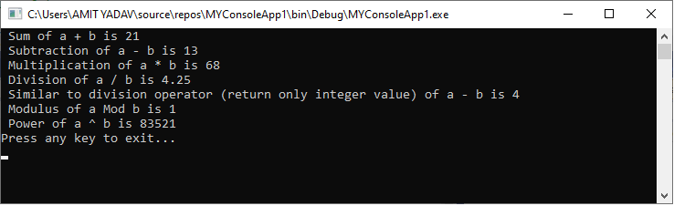

**Comparison Operators**

As the name suggests, the Comparison Operator is used to compare the value of two variables or operands for the various condition such as greater, less than or equal, etc. and returns a Boolean value either true or false based on the condition.

|  |  |  |
| --- | --- | --- |
| **Operator** | **Description** | **Example** |
| **=** | It checks whether the value of the two operands is equal; If yes, it returns a true value, otherwise it shows False. | (A = B) |
| **<>** | It is a Non-Equality Operator that checks whether the value of the two operands is not equal; it returns true; otherwise, it shows false. | (A <> B), check Non-Equality |
| **>** | A greater than symbol or Operator is used to determine whether the value of the left operand is greater than the value of the right operand; If the condition is true, it returns TRUE; otherwise, it shows FALSE value. | (A > B); if yes, TRUE,  Else FALSE |
| **<** | It is a less than symbol which checks whether the value of the left operand is less than the value of the right operand; If the condition is true, it returns TRUE; otherwise, it shows FALSE value. | (A < B); if the condition is true, returns TRUE else FALSE |
| **>=** | It is greater than equal to which checks two conditions whether the first operand is greater than or equal to the second operand; if yes, it returns TRUE; otherwise, it shows False. | A >= B |
| **<=** | This symbol represents less than equal to which determines the first operand is less than or equal to the second operand, and if the condition is true, it returns TRUE; otherwise, it shows FALSE. | A <= B |
| **Is** | The Is Operator is used to validate whether the two objects reference the same variable or object; If the test is true, it returns True; otherwise, the result is False. In short, it checks the equality of the objects. An Is Operator is also used to determine whether the object refers to a valid object. | result = obj1 Is obj2 |
| **IsNot** | The IsNot Operator is similar to Is Operator, except that the two object references the different object; if yes, the result is True; otherwise, the result is False. | Result = obj1 IsNot obj2 |
| **Like** | The Like Operator is used to check the pattern expression of string variable; And if the pattern matched, the result is True; otherwise, it returns False. | result = string Like the pattern, the pattern represents the series of characters used by Like Operator. |

Example of **Comparison Operators in VB.NET**

**Comparison_Operator.vb**

Imports System

Module Comparison_Operator

    Sub Main()

        'declaration of Integer, Object and String Data Type variables

        Dim x As Integer = 5

        Dim y As Integer = 10

        Dim Result, obj, obj2 As Object

        Dim str, str2 As String

        str = "Apple12345"

        str2 = "Apple12345"

        obj = 10

        obj2 = 20

        Console.WriteLine(" Program of Comparison Operator")

        'Use of > Operator

        Console.WriteLine(" Output of x > y is {0}", x > y)

        'Use of < Operator

        Console.WriteLine(" Output of x < y is {0}", x < y)

        'Use of = Operator

        Console.WriteLine(" Output of x = y is {0}", x = y)

        'Use of <> Operator

        Console.WriteLine(" Output of x <> y is {0}", x <> y)

        'Use of >= Operator

        Console.WriteLine(" Output of x >= y is {0}", x >= y)

        'Use of <= Operator

        Console.WriteLine(" Output of x <= y is {0}", x <= y)

        'Use of Is Operator

        Result = obj Is obj2

        Console.WriteLine(" Output of obj Is obj2 is {0}", Result)

        'Use of Is Operator

        Result = obj IsNot obj2

        Console.WriteLine(" Output of obj IsNot obj2 is {0}", Result)

        'Use of Like Operator

        Result = str Like str2

        Console.WriteLine(" Output of str Like str2 is {0}", Result)

        Console.WriteLine(" Press any key to exit...")

        Console.ReadKey()

    End Sub

End Module

Now compile and execute the above code by pressing the F5 button or Start button in Visual studio, it returns the following output:

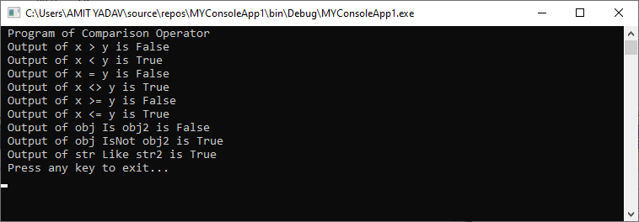

**Logical and Bitwise Operators**

The logical and bitwise Operators work with Boolean (true or false) conditions, and if the conditions become true, it returns a Boolean value. The following are the logical and bitwise Operators used to perform the various logical operations such as And, Or, Not, etc. on the operands (variables). Suppose there are two operand A and B, where A is True, and B is False.

|  |  |  |
| --- | --- | --- |
| **Operator** | **Description** | **Example** |
| **And** | The And Operator represents, whether both the operands are true; the result is True. | (A And B), result = False |
| **Or** | It is an Or Operator that returns a true value; if anyone operand is true from both the operands. | (A Or B), result = True |
| **Not** | The Not Operator is used to reverse the logical condition. For example, if the operand's logic is True, it reveres the condition and makes it False. | Not A  Or  Not(A And B) is True |
| **Xor** | It is an Exclusive OR Operator that represents, whether both the expression is true or false, the result is True; otherwise, the result is False. | A Xor B is True |
| **AndAlso** | It is a logical AND Operator that performs short-circuit operation on the variables, and if both the operands are true, the result is True else the result is False. | A AndAlso B = False |
| **OrElse** | It is a logical OR Operator that perform short-circuit operation on Boolean data. If anyone of the operand is true, the result is True else the result is False. | A OrElse B = True |
| **IsFalse** | The IsFalse Operator is used to determine whether an expression is False. |  |
| **IsTrue** | The IsTrue Operator is used to determine whether an expression is True. |  |

Example of **Logical and Bitwise Operator:**

**Logic_Bitwise.vb**

Imports System

Module Logic_Bitwise

    Sub Main()

        Dim A As Boolean = True

        Dim B As Boolean = False

        Dim c, d As Integer

        c = 10

        d = 20

        'Use of And Operator

        If A And B Then

            Console.WriteLine(" Operands A And B are True")

        End If

        'Use of Or Operator

        If A Or B Then

            Console.WriteLine(" Operands A Or B are True")

        End If

        'Use of Xor Operator

        If A Xor B Then

            Console.WriteLine(" Operands A Xor B is True")

        End If

        'Use of And Operator

        If c And d Then

            Console.WriteLine(" Operands c And d is True")

        End If

        'Use of Or Operator

        If c Or d Then

            Console.WriteLine(" Operands c Or d is True")

        End If

        'Use of AndAlso Operator

        If A AndAlso B Then

            Console.WriteLine(" Operand A AndAlso B is True")

        End If

        'Use of OrElse Operator

        If A OrElse B Then

            Console.WriteLine(" Operand A OrElse B is True")

        End If

        'Use of Not Operator

        If Not (A And B) Then

            Console.WriteLine(" Output of Not (A And B) is True")

        End If

        Console.WriteLine(" Press any key to exit?")

        Console.ReadKey()

    End Sub

End Module

Now compile and execute the above code by pressing the F5 button or Start button in Visual studio, it returns the following output:

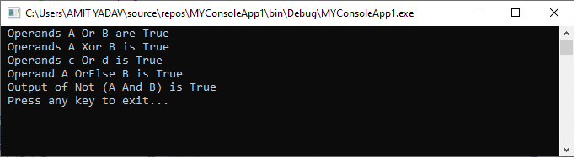

**Bit Shift Operators**

The Bit Shit Operators are used to perform the bit shift operations on binary values either to the right or to the left.

**Bit Shift operations in VB.NET**

|  |  |
| --- | --- |
| **Operator** | **Description** |
| **AND** | The Binary AND Operator are used to copy the common binary bit in the result if the bit exists in both operands. |
| **OR** | The Binary OR Operator is used to copy a common binary bit in the result if the bit found in either operand. |
| **XOR** | The Binary XOR Operator in VB.NET, used to determine whether a bit is available to copy in one operand instead of both. |
| **Not** | The binary NOT Operator is also known as the binary Ones' Compliment Operator, which is used to flip binary bits. This means it converts the bits from 0 to 1 or 1 to 0 binary bits. |
| **<<** | The Binary Left Shift Operator is used to shift the bit to the left side. |
| **>>** | The Binary Right Shift Operator is used to shift the bit to the right side. |

Example of **Bit Shift Operator in VB.NET:**

**BitShift_Operator.vb**

Imports System

Module Bitshift_Operator

    Sub Main()

        Dim x, y, z As Integer

        x = 12

        y = 25

        Dim a, b As Double

        a = 5 ' a = 5(00000101)

        b = 9 ' b = 9(00001001)

        ' Use of And Operator

        z = x And y

        Console.WriteLine(" BitShift Operator x And y is {0}", z)

        'Use of Or Operator

        z = x Or y

        Console.WriteLine(" BitShift Operator x Or y is {0}", z)

        z = x Xor y

        Console.WriteLine(" BitShift Operator x Xor y is {0}", z)

        z = Not y

        Console.WriteLine(" BitShift Operator Not y is {0}", z)

        'Use of << Left-Shift Operator

        ' Output is 00001010

        Console.WriteLine(" Bitwise Left Shift Operator - a<<1 = {0}", a << 1)

        'Output is 00010010

        Console.WriteLine(" Bitwise Left Shift Operator - b<<1 = {0}", b << 1)

        'Use of >> Right-Shift Operator

        'Output is 00000010

        Console.WriteLine(" Bitwise Right Shift Operator - a>>1 = {0}", a << 1)

        'Output is 00000100

        Console.WriteLine(" Bitwise Right Shift Operator - b>>1 = {0}", a << 1)

        Console.WriteLine(" Press any key to exit...")

        Console.ReadKey()

    End Sub

End Module

Now compile and execute the above code by pressing the F5 button or Start button in Visual studio, it returns the following output:

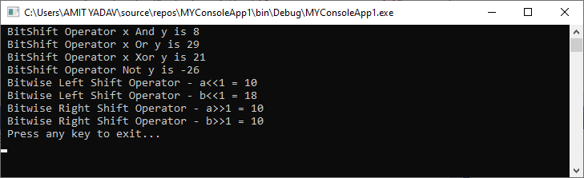

**Assignment Operators**

The Assignment Operators are used to assign the value to variables in VB.NET.

**Assignment Operators in VB.NET**

|  |  |  |
| --- | --- | --- |
| **Operator** | **Description** | **Example** |
| **=** | It is a simple assignment Operator used to assign a right-side operand or value to a left side operand. | X = 5, X assign a value 5 X = P + Q, (P + Q) variables or value assign to X. |
| **+=** | An Add AND assignment Operator is used to add the value of the right operand to the left operand. And the result is assigned to the left operand. | X += 5, which means X= X+5 ( 5 will add and assign to X and then result saved to Left X operand) |
| **-=** | It is a Subtract AND assignment Operator, which subtracts the right operand or value from the left operand. And then, the result will be assigned to the left operand. | X -= P, which is same as X = X - P |
| **\*=** | It is a Multiply AND assignment Operator, which multiplies the right operand or value with the left operand. And then, the result will be assigned to the left operand. | X *= P, which is same as X = X - P |
| **/=** | It is a Divide AND assignment Operator, which divides the left operand or value with the right operand. And then, the result will be assigned to the left operand (in floating-point). | X /= P, which is same as X = X - P |
| **\=** | It is a Divide AND assignment Operator, which divides the left operand or value with the right operand. And then, the result will be assigned to the left operand (in integer-point division). | X \= P, which is same as X = X - P |
| **^=** | It is an expression AND assignment Operator, which raises the left operand or value to the right operand's power. And then, the result will be assigned to the left operand. | X ^= P, which is same as X = X ^ P |
| **&=** | It is a concatenate string assignment Operator used to bind the right-hand string or variable with the left-hand string or variable. And then, the result will be assigned to the left operand. | Str &= name, which is same as Str = Str & name |

Example of **Assignment Operator** in VB.NET:

**Assign_Operator.vb**

Imports System

Module Assign_Operator

    Sub Main()

        'Declare variable and b As Integer

        Dim A As Integer = 5

        Dim B As Integer

        Dim Str, name As String

        name = "come"

        Str = "Wel"

        'Use of = Operator

        B = A

        Console.WriteLine(" Assign value A to B is {0}", B)

        'Use of += Operator

        B += A

        Console.WriteLine(" Output of B += A is {0}", B)

        'Use of -= Operator

        B -= A

        Console.WriteLine(" Output of B -= A is {0}", B)

        'Use of *= Operator

        B *= A

        Console.WriteLine(" Output of B *= A is {0}", B)

        'Use of /= Operator

        B /= A

        Console.WriteLine(" Output of B /= A is {0}", B)

        'Use of = Operator

        B \= A

        Console.WriteLine(" Output of B \= A is {0}", B)

        'Use of ^= Operator

        B ^= A

        Console.WriteLine(" Output of B ^= A is {0}", B)

        'Use of &= Operator

        Str &= name

        Console.WriteLine(" Output of Str &= name is {0}", Str)

        Console.WriteLine(" Press any key to exit...")

        Console.ReadKey()

    End Sub

End Module

Now compile and execute the above code by pressing the F5 button or Start button in Visual studio, it returns the following output:

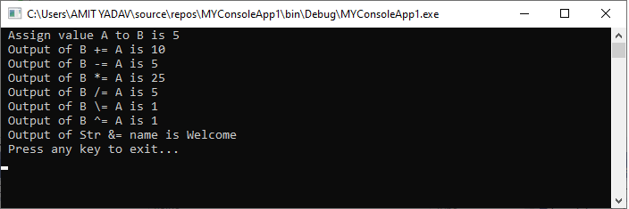

**Concatenation Operators**

In VB.NET, there are two concatenation Operators to bind the operands:

|  |  |  |
| --- | --- | --- |
| **Operator** | **Description** | **Example** |
| **&** | It is an ampersand symbol that is used to bind two or more operand together. Furthermore, a nonstring operand can also be concatenated with a string variable ( but in that case, Option Strict is on). | Result = Wel & come, Result = Welcome |
| **+** | It is also used to add or concatenate two number or string. | Result = Wel + come, Result = Welcome |

**Example of Concatenation Operators in VB.NET.**

**MyProgram.vb**

Imports System

Module MyProgram

    Sub Main()

        Dim str As String = "Wel"

        Dim str2 As String = "come"

        Dim str3 As String = " "

        Dim str4 As String = "to JavatPoint"

        Dim result As String

        Dim result2 As String

        result = str & str2

        Console.WriteLine(" Result = str & str2 gives = {0}", result)

        result2 = str + str2 + str3 + str4

        Console.WriteLine(" Result = str + str2 + str3 +str4 gives = {0}", result2.ToString)

  Console.ReadLine()

    End Sub

End Module

Now compile and execute the above code by pressing the F5 button or Start button in Visual studio, it returns the following output:

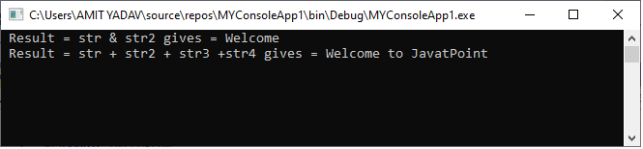

**Miscellaneous Operators**

There are some important Operator in VB.NET

|  |  |  |
| --- | --- | --- |
| **Operator** | **Description** | **Example** |
| Await | An Await Operator is used in an operand to suspend the execution of an asynchronous method or lambda expression until the awaited task completes. | Dim output as out = Await AsyncMethodThatReturnsResult() Await AsyncMethod() |
| AddressOf | The AddressOf Operator is used to provide a reference to the address of a procedure. | AddHandler Button2.Click, AddressOf Button2_Click |
| GetType | A GetType Operator is used to retrieve the type of the specified object. In addition, the retrieved object type provides various information such as methods, properties, and events. | MsgBox(GetType(String).ToString()) |
| Function Expression | It defines the lambda expression, which declares the parameter and code. A Lambda expression is a function that is used to calculate and return value without defining the name. | Dim mul2 = Function(num As Integer) num * 4 Console.WriteLine(mul2(4)) |
| If | The If Operator using short circuit evaluation to conditionally return a single object value from two defined object values. The If Operator can be used with two or three defined arguments. | Dim a = -4 Console.WriteLine(If (a >= 0, "Positive", "Negative")) |

Example of **Miscellaneous Operator**s in VB.NET.

**Misc_Operator.vb**

Imports System

Module Misc_Operator

    Sub Main()

        ' Initialize a variable

        Dim a As Integer = 50

        ' GetType of the Defined Type

        Console.WriteLine(GetType(Double).ToString())

        Console.WriteLine(GetType(Integer).ToString())

        Console.WriteLine(GetType(String).ToString())

        Console.WriteLine(GetType(Single).ToString())

        Console.WriteLine(GetType(Decimal).ToString())

        'Use of Function()

        Dim multiplywith10 = Function(sum As Integer) sum * 10

        Console.WriteLine(multiplywith10(10))

        Console.WriteLine(If(a >= 0, "Negative", "Positive"))

        Console.WriteLine(" Press any key to exit...")

        Console.ReadLine()

    End Sub

End Module

Now compile and execute the above code by pressing the F5 button or Start button in Visual studio, it returns the following output:

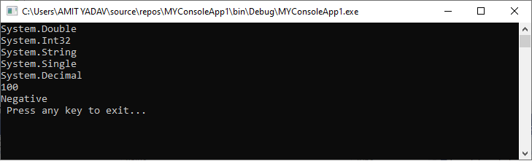

**Operator Precedence in VB.NET**

Operator precedence is used to determine the order in which different Operators in a complex expression are evaluated. There are distinct levels of precedence, and an Operator may belong to one of the levels. The Operators at a higher level of precedence are evaluated first. Operators of similar precedents are evaluated at either the left-to-right or the right-to-left level.

The Following table shows the operations, Operators and their precedence -

|  |  |  |
| --- | --- | --- |
| **Operations** | **Operators** | **Precedence** |
| **Await** |  | Highest |
| **Exponential** | **^** |  |
| **Unary identity and negation** | **+, -** |  |
| **Multiplication and floating-point division** | **\*, /** |  |
| **Integer division** | **\** |  |
| **Modulus arithmetic** | **Mod** |  |
| **Addition and Subtraction** | **+, -** |  |
| **Arithmetic bit shift** | **<<, >>** |  |
| **All comparison Operators** | **=, <>, <, <=, >, >=, Is, IsNot, Like, TypeOf …is** |  |
| **Negation** | **Not** |  |
| **Conjunction** | **And, AndAlso** |  |
| **Inclusive disjunction** | **Or, Else** |  |
| **Exclusive disjunction** | **Xor** | Lowest |

Example of **Operator Precedence in VB.NET.**

**Operator_Precedence.vb**

Imports System

Module Operator_Precedence

    Sub Main()

        'Declare and Initialize p, q, r, s variables

        Dim p As Integer = 30

        Dim q As Integer = 15

        Dim r As Integer = 10

        Dim s As Integer = 5

        Dim result As Integer

        Console.WriteLine("Check Operator Precedence in VB.NET")

        'Check Operator Precedence

        result = (p + q) * r / s      '  45 * 10 / 5

        Console.WriteLine("Output of (p + q) * r / s is : {0}", result)

        result = (p + q) * (r / s)   ' (45) * (10/5)

        Console.WriteLine("Output of (p + q) * (r / s) is  : {0}", result)

        result = ((p + q) * r) / s    ' (45 * 10 ) / 5

        Console.WriteLine("Output of ((p + q) * r) / s is  : {0}", result)

        result = p + (q * r) / s     '  30 + (150/5)

        Console.WriteLine("Output of p + (q * r) / s is  : {0}", result)

        result = ((p + q * r) / s)     '  ((30 + 150) /5)

        Console.WriteLine("Output of ((p + q * r) / s) is  : {0}", result)

        Console.WriteLine(" Press any key to exit...")

        Console.ReadKey()

    End Sub

End Module

Now compile and execute the above code by pressing the F5 button or Start button in Visual studio, it returns the following output:

